Structured programming -lab
Course code: cse 1383
Assignment project
Title: medicine stock and expiry management for a community health center

Submitted to:

Abdullah Mohammad sakib
lecturer
Department of computer science and technology

Submitted by:

Tawhidul islam
Id:26103042
Program: BCSE
Section: D
Serial :9
Submission: 6-9-2026



IUBAT- international university of business agricultural and technology

1. Introduction

1.1 Background
A community health center depends on the continuous and reliable availability of essential medicines to serve the patients who visit it. The quantity of any given medicine held in store is not a static figure; it changes on a near-daily basis as a result of ongoing patient consumption, occasional bulk issues, and periodic replenishment from suppliers. Because the center typically operates with limited storage space, a limited procurement budget and a limited window in which newly received stock can be expected to arrive, the way in which the available quantity of every medicine is monitored has a direct and material bearing on the quality of care that the center is able to provide.
Two opposing failure modes characterize poor stock management in this setting. On one hand, an excessively cautious approach that keeps very large quantities of every medicine in store reduces the likelihood of an outright shortage, but increases the likelihood that a portion of that stock will remain unused when its expiry period is reached, resulting in wastage of medicine, of the funds spent to procure it, and of the storage capacity it occupied. On the other hand, an excessively lean approach that keeps only small quantities in store reduces the likelihood of such wastage, but increases the likelihood that a sudden increase in patient demand, or a delay in the next scheduled supply, will leave the center without a medicine that a patient urgently requires.
The problem is further complicated by the fact that not every medicine carries the same clinical weight. A medicine that is essential to patient care, and for which no substitute is readily available, must not be allowed to fall into shortage even briefly, whereas a temporary and brief shortage of a comparatively routine medicine may be tolerated with far less consequence. Similarly, a medicine that currently shows a comfortable stock level may still deserve managerial attention if a substantial share of that stock is approaching the end of its usable shelf life and is unlikely to be consumed in time.

1.2 Objective of the Developed Program
The objective of this assignment is to design and implement, in the C programming language, a structured software solution that examines the current medicine stock of a community health center, identifies medicines exposed to shortage risk, expiry risk, or a combination of both, determines an appropriate order in which the medicines should receive managerial attention, and produces an organized, file-recorded report that the management of the center can act upon. The program is required to operate correctly not only on the six medicines supplied for the purposes of this assignment, but on any comparable dataset of medicine records, since the values used for demonstration are illustrative rather than fixed.

2. Problem Analysis
The dataset supplied for the purpose of this assignment, and used throughout this report for illustration, is reproduced below.
Medicine Code | Medicine Name | Available Stock | Avg. Daily Requirement | Minimum Stock Level | Days Remaining to Expiry | Essentiality Level
MED01 | Oral Saline | 120 | 35 | 80 | 45 | 3
MED02 | Paracetamol | 300 | 40 | 100 | 120 | 2
MED03 | Insulin | 60 | 12 | 50 | 30 | 3
MED04 | Amoxicillin | 200 | 25 | 80 | 20 | 3
MED05 | Antacid | 250 | 18 | 60 | 15 | 1
MED06 | Cetirizine | 180 | 15 | 50 | 90 | 1

2.1 Major Requirements
- Represent, for each medicine, its code, name, available stock, average daily requirement, minimum stock level, days remaining to expiry and essentiality level, in a manner that keeps these seven attributes correctly associated with one another under every operation performed by the program.
- Derive, from the stored attributes, further quantities that are useful for decision-making but are not themselves supplied directly, most notably the number of days for which the present stock is expected to remain available under the recorded average demand.
- Classify every medicine into a stock condition that reflects its actual situation, rather than a single generic status.
- Rank the medicines in an order that reflects the urgency with which each one requires managerial attention, and resolve ties between medicines of equal computed urgency in a defensible manner.
- Provide a facility through which a member of staff can look up a single medicine by an identifying value and see its full current status.
- Allow the available stock of a medicine to be corrected upward, on receipt of new supply, or downward, on issue to a patient, without ever allowing the recorded stock to become negative, and ensure that the medicine's derived status is updated immediately afterwards.
- Produce a final, organized report, together with a summary of how many medicines fall into each category of concern, and preserve this report in a file for later reference.

2.2 Stock-Related Constraints
The available stock of every medicine must be compared against two distinct reference points: the minimum stock level, which represents the threshold below which the centre considers the medicine to be under-stocked, and the average daily requirement, which represents the rate at which the stock is actually consumed. A medicine can be below its minimum stock level and yet still have several days of coverage remaining if its daily requirement is modest; conversely, a medicine can be above its minimum stock level and yet face a genuine shortage risk within a short time if its daily requirement is comparatively high. Both figures must therefore be considered together rather than in isolation, and the analysis must not rely on the available stock figure alone.

2.3 Expiry-Related Constraints
The days remaining to expiry indicates how much time is left before a medicine's current batch can no longer be safely dispensed. A large available stock does not, by itself, indicate a healthy stock position if the remaining shelf life is short and the recorded daily requirement is not high enough to consume the stock before that period elapses. The program must therefore estimate, for every medicine, whether the quantity currently held is realistically expected to be consumed within the remaining expiry period, and treat any portion that is not expected to be consumed in time as being at risk of wastage, independently of whether the same medicine is also short of its minimum stock level.

2.4 Conflicting Requirements
Several of the requirements identified above pull the proposed solution in opposing directions, and the engineering considerations stated in the assignment brief must be reconciled rather than resolved in favor of one side alone. These conflicting pairs are summarized below.
Requirement | Conflicting Requirement
Maintain sufficient medicine stock | Avoid excessive stock and expiry-related wastage
Replenish low-stock medicine | Avoid unnecessary replenishment when existing stock may expire
Give priority to essential medicine | Attend to other medicines having immediate expiry risk
Maintain a simple decision method | Consider sufficient information for a reliable decision
Process stock information accurately | Avoid unnecessary repeated calculations and processing

The proposed solution, described in the following section, is designed to hold a reasoned balance between each of these opposing pairs rather than to optimize any single one of them in isolation.

3. Proposed Solution

3.1 Method Used to Analyze Stock
For every medicine, the program derives an estimated stock-coverage period, expressed in days, by dividing the available stock by the average daily requirement. This single derived quantity is central to the remainder of the analysis, since it converts an absolute stock figure into a time-based measure that can be meaningfully compared against the minimum stock level, expressed as an equivalent coverage period, and against the days remaining to expiry, which is already expressed in the same unit. The stock-coverage period is calculated once for a given set of recorded values and reused wherever it is needed afterwards, rather than being recalculated repeatedly, in keeping with the optimization requirement of the assignment.
In addition to the stock-coverage period, the program estimates the quantity of a medicine that is realistically expected to be consumed before its recorded expiry period is reached, by multiplying the average daily requirement by the days remaining to expiry. Comparing this expected consumption against the available stock allows the program to determine, for every medicine, whether any portion of the current stock is likely to remain unused when it expires, which is the basis of the expiry-related decision described in the next subsection.

3.2 Method Used to Identify Stock Condition
Rather than relying on the available stock figure in isolation, the proposed classification considers, jointly, the relationship of the available stock to the minimum stock level, the estimated stock-coverage period relative to the essentiality level of the medicine, and the estimated expiry exposure derived above. On this combined basis, each medicine is assigned to one of the following five conditions.
Stock Condition | Governing Situation (Informal Description)
Sufficient Stock | Available stock is at or above the minimum stock level, the estimated stock-coverage period comfortably exceeds the time needed for the next replenishment cycle, and no significant expiry concern exists.
Reorder Required | Available stock has fallen below the minimum stock level, or the estimated stock-coverage period is short, but the medicine is not of the highest essentiality and no immediate patient-care risk is indicated.
Urgent Reorder | Available stock is below the minimum stock level for a medicine of high essentiality, or the estimated stock-coverage period is shorter than the time realistically required to obtain fresh supply.
Expiry Attention | Available stock is sufficient (at or above the minimum stock level) but a considerable portion of that stock is not expected to be consumed before the recorded expiry period, indicating a risk of wastage.
Critical Condition | The medicine simultaneously exhibits shortage risk (low stock relative to demand) and expiry risk (short remaining shelf life), or is an essential medicine whose coverage period is shorter than its remaining expiry period, requiring combined and immediate managerial decision-making.

The distinguishing feature of this classification, compared with a scheme based on the available stock alone, is that it separates a medicine that is genuinely short of stock from a medicine that merely appears well-stocked but is exposed to wastage, and it additionally recognizes that a medicine can display both concerns at once, in which case it is placed in the Critical Condition category rather than under either concern alone.

3.3 Method Used to Determine Management Priority
Because the center cannot address every outstanding stock concern simultaneously, the medicines must be placed in an order that reflects the urgency of managerial attention each one requires. The proposed method combines the factors listed below into a single, comparable priority indicator for every medicine, rather than ranking the medicines on any one factor alone.
Factor | Symbol | Interpretation in the Priority Score
Essentiality Level | E | Higher essentiality contributes a larger share of the priority score, since a shortage of an essential medicine has more serious consequences for patient care.
Shortage Severity | S | Computed from how far the available stock has fallen below the minimum stock level, expressed as a proportion; a medicine already below its minimum level contributes more strongly than one merely approaching it.
Stock Coverage (days) | C | The number of days the current stock is expected to last under average daily consumption; a shorter coverage period increases urgency.
Expiry Urgency | X | Derived from the days remaining to expiry; a medicine nearing expiry, particularly one that also shows shortage risk, contributes a higher urgency component.
Combined Risk Indicator | R | A supplementary indicator that increases the score further when both shortage risk and expiry risk are present simultaneously, reflecting the added managerial complexity of such cases.

A medicine of high essentiality that is already below its minimum stock level, and whose estimated coverage period is short, receives the highest combined priority indicator and is therefore placed at the top of the management-attention order. A medicine that shows only a mild expiry exposure, with sufficient stock and lower essentiality, receives a comparatively low priority indicator and is placed toward the bottom of the order. Because the priority indicator for a given medicine depends only on values that have already been derived while analyzing that medicine's stock condition, it is computed directly from those stored, previously calculated results rather than by re-examining the raw data a second time, again in keeping with the optimization requirement.

3.4 Method Used to Resolve Equal-Priority Cases
Where two or more medicines produce an identical, or near-identical, combined priority indicator, the proposed solution resolves the tie through a short sequence of secondary comparisons applied in order: first, the medicine with the higher essentiality level is placed ahead; second, if the essentiality levels are also equal, the medicine with the shorter estimated stock-coverage period is placed ahead, since it faces the more immediate risk of running out; and third, if the coverage periods are also equal, the medicine with fewer days remaining to expiry is placed ahead, since its exposure window is narrower. This sequence of tie-breaking comparisons is deterministic, requires no additional data beyond what has already been derived, and reflects the same clinical reasoning applied to the primary ranking itself.

3.5 Handling Stock and Expiry Conflict
The assignment brief specifically requires that the proposed solution not automatically recommend additional stock for every medicine that appears low, without regard to whether the same or another medicine is simultaneously carrying a quantity that will expire shortly. The proposed solution addresses this by keeping the shortage indicator and the expiry indicator described above logically separate from one another throughout the analysis, rather than merging them into a single undifferentiated flag. A medicine is reported as facing shortage risk only on the basis of its stock-coverage period relative to its minimum stock level; it is reported as facing expiry risk only on the basis of its expected consumption relative to its recorded expiry period; and it is reported as facing combined risk only when both conditions are met at once. This separation allows the final report to state plainly, for each medicine, which of the two concerns applies, so that the center’s management is not misled into ordering fresh stock of a medicine whose real difficulty is that existing stock is about to expire unused, nor into overlooking a medicine that is both short of stock and carrying batches close to expiry, which represents the most demanding case for managerial decision-making.

4. Program Design

4.1 Data Organization
Each medicine is represented as a single structured record containing its code, name, available stock, average daily requirement, minimum stock level, days remaining to expiry and essentiality level as supplied, together with derived fields for the estimated stock-coverage period, the estimated expiry exposure, the assigned stock condition and the computed priority indicator. The complete set of medicine records is held in a single array of such structures, sized to accommodate the supplied dataset while remaining straightforward to extend if the number of medicines changes, in line with the requirement that the program continue to operate correctly when the supplied values are changed. Holding the derived fields alongside the supplied fields, within the same record, avoids the need for separate parallel arrays and ensures that every value associated with a given medicine moves together whenever the array is rearranged, searched or updated.

4.2 Major Functions
The proposed solution is organized into a small number of clearly separated functions, each responsible for a single aspect of the overall task, so that repeated operations are implemented once and reused wherever they are required. The intended responsibility of each function is summarized below; the corresponding source code is presented separately as part of the submitted implementation.
Proposed Function (Purpose) | Responsibility
Data initialization routine | Loads the medicine records (code, name, available stock, average daily requirement, minimum stock level, days remaining to expiry, essentiality level) into the chosen data structure at program start-up, from either in-code initial values or an input file, so that the six supplied medicines and any future dataset of different size can be accommodated without changing the program logic.
Stock-coverage calculator | Derives, for a given medicine record, the estimated number of days the available stock will last under the recorded average daily requirement, and stores the result so that it need not be recalculated every time it is referenced elsewhere in the program.
Expiry-exposure calculator | Derives, for a given medicine record, the quantity that is expected to remain unused at the recorded expiry period under the current consumption rate, distinguishing genuine expiry risk from a simple shortage.
Stock-condition classifier | Applies the reasoned decision rules to the stock-coverage and expiry-exposure results, together with the minimum stock level and essentiality level, to assign one of the defined stock-condition categories to the medicine.
Priority evaluator | Combines essentiality, shortage severity, stock coverage and expiry urgency into a single comparable priority indicator for each medicine, and resolves equal-priority cases using the secondary and tertiary comparison rules described in the Proposed Solution section.
Search routine | Accepts an identifying value (the medicine code, or alternatively the medicine name) from the user and locates the corresponding record, reporting an appropriate message when no match exists.
Ordering routine | Arranges the medicine records according to the selected criterion (management priority, by default) using a sorting technique appropriate to the small, in-memory dataset, while keeping all fields of a record correctly associated with one another during the rearrangement.
Stock-update routine | Adjusts the available stock of a specified medicine, upward on receipt of new stock or downward on issue to patients, rejects any update that would drive the available stock below zero, and triggers recalculation of only the affected medicine's derived values.
Report generator | Produces the final, organized report (per-medicine figures and the summary counts) on screen and writes the corresponding output to a file.
Menu / control routine | Presents the available operations to the user, accepts a selection, and calls the corresponding routine, allowing the program to be exercised repeatedly during demonstration without restarting.

4.3 Algorithm / Pseudocode
The overall control flow of the proposed program, expressed at a level intended to convey the reasoning of the solution rather than the C-language syntax of its implementation, proceeds as follows.
- Load the supplied medicine records into the array of structures described in Section 5.1.
- For every record in the array, in a single pass: derive its stock-coverage period from its available stock and average daily requirement; derive its expiry-exposure quantity from its average daily requirement and days remaining to expiry; assign a stock condition using the rules described in Section 4.2; and compute a priority indicator using the method described in Section 4.3. Store each derived value in the record itself so that it is not recalculated in any later step.
- Present the user with a menu of the operations supported by the program: search for a medicine, update the stock of a medicine, view the medicines ordered by priority (or another selected criterion), and generate the final report.
- If the user selects the search operation, accept an identifying value, examine the array for a matching record, and display its full stored and derived information, or an appropriate not-found message if no match exists.
- If the user selects the update operation, accept the medicine to be updated and the nature of the change (receipt of new stock or issue to patients), apply the change to the available stock field while preventing it from becoming negative, and then re-derive only the stock-coverage period, expiry exposure, stock condition and priority indicator of that single affected record, leaving every other record untouched.
- If the user selects the ordering operation, arrange the array according to the selected criterion, using the previously derived priority indicator (or another selected field) as the sort key, applying the equal-priority resolution sequence described in Section 4.4 where required, and keeping every field of a record together during any exchange of position.
- If the user selects the report operation, iterate over the (optionally ordered) array once, writing the medicine code, name, available stock, estimated stock coverage, days remaining to expiry, essentiality level, stock condition and management priority of every record to the screen and to an output file, and accumulate, in the same pass, the summary counts of medicines requiring reorder, requiring urgent attention, and showing expiry concern, together with the identity of the medicine holding the highest management priority.
- Return to the menu until the user chooses to end the program.

4.4 Flowchart Description
The corresponding flow proceeds, at a high level, from program start, through the one-time loading and analysis of the dataset described in Step 2 above, into a repeating menu loop that offers the search, update, ordering and reporting operations as separate branches. Each branch performs its operation and then returns control to the menu, so that the loading and initial analysis step is executed exactly once, while the operations that depend on it may be exercised repeatedly, including by the course instructor during demonstration, without repeating the initial analysis unnecessarily. The loop terminates only when the user selects the exit option, at which point the program ends.

5. Optimization Considerations
The proposed design applies the optimization requirement of the assignment in the following specific ways.
- Single-pass derivation: the stock-coverage period, expiry exposure, stock condition and priority indicator of every medicine are each calculated exactly once, immediately after the data is loaded, and stored within the record itself, rather than being recalculated every time the record is displayed, searched, ordered or reported.
- Localized recalculation on update: when the available stock of a single medicine is changed, only that medicine's derived values are recalculated; the derived values of every other medicine, which are unaffected by the change, are left untouched.
- Reuse of previously identified records: once the search routine has located a medicine, its position in the array is used directly by any subsequent operation requested on that same medicine within the same interaction, rather than searching for it again.
- Consolidated data structure: keeping every attribute of a medicine, supplied and derived, within one structured record removes the need for separate parallel arrays that would otherwise have to be kept synchronized by hand, which would itself be a source of redundant processing and potential inconsistency.
- Single-pass reporting: the summary counts required in the final report (medicines requiring reorder, requiring urgent attention, showing expiry concern, and the medicine of highest priority) are accumulated during the same pass over the array that produces the per-medicine report lines, rather than in a separate pass.
- Selection of a sorting technique proportionate to the dataset: given the small number of medicine records expected in this setting, a straightforward comparison-based sorting technique is considered sufficient and is preferred over a more elaborate technique whose additional complexity would not be justified by the size of the dataset.

6. code

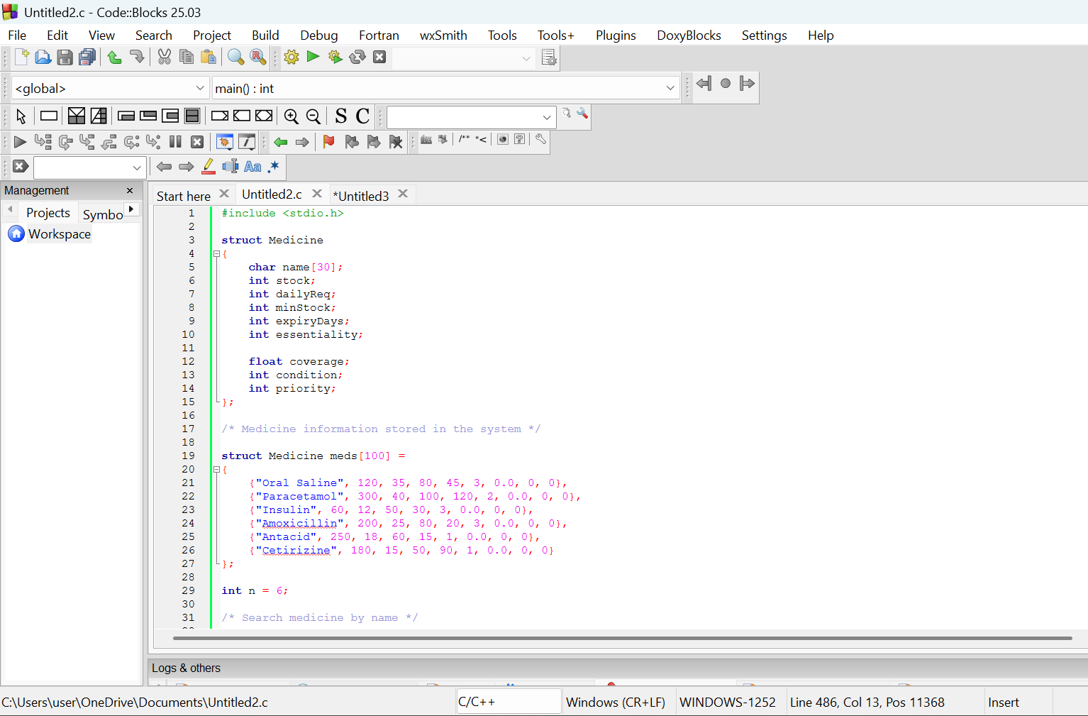

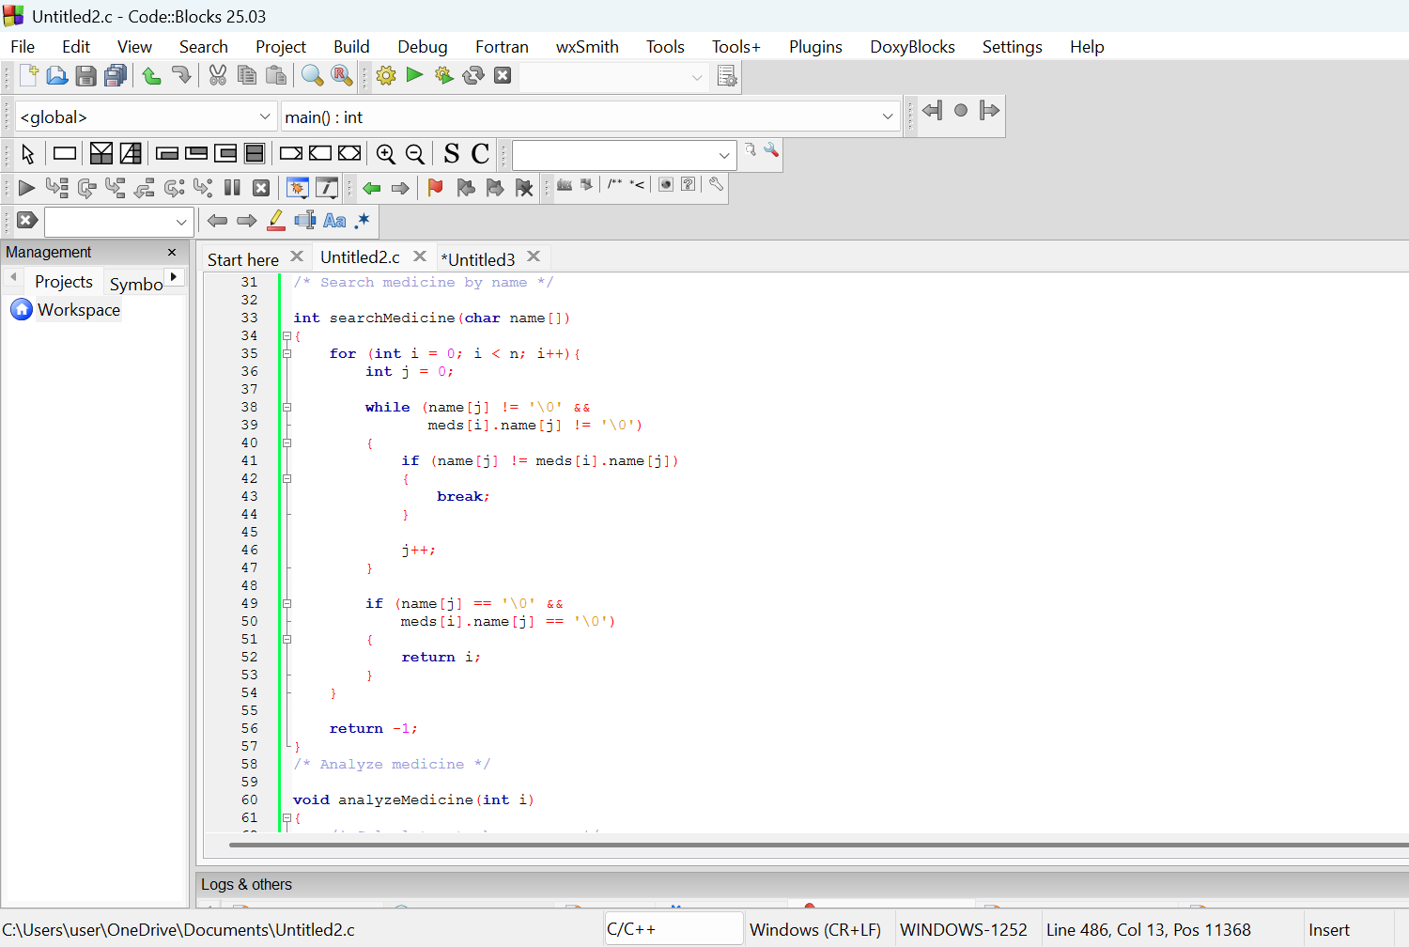

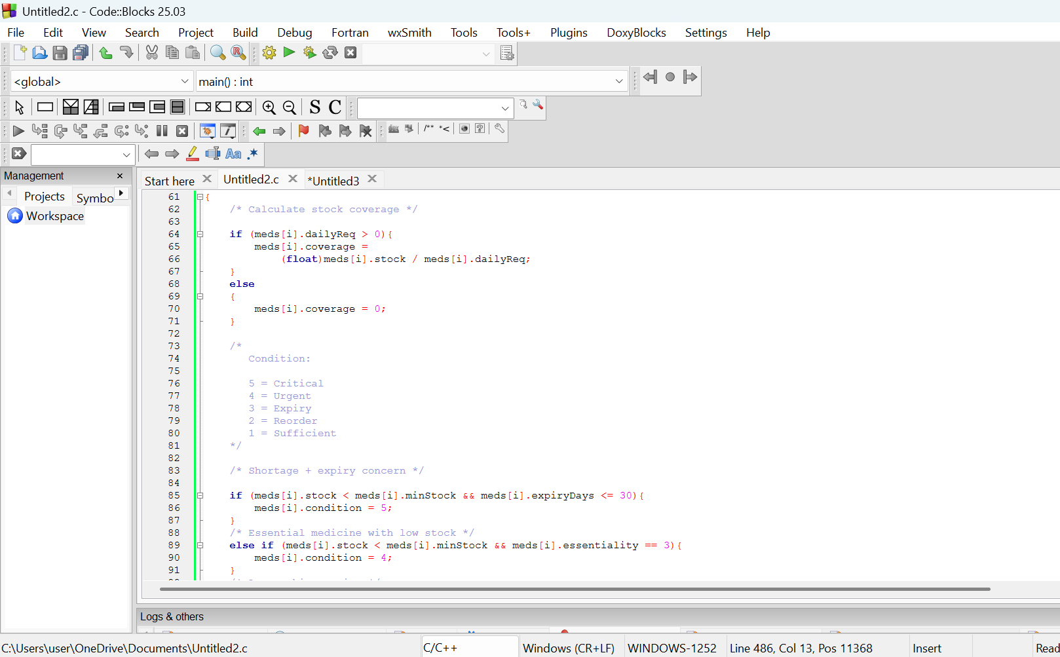

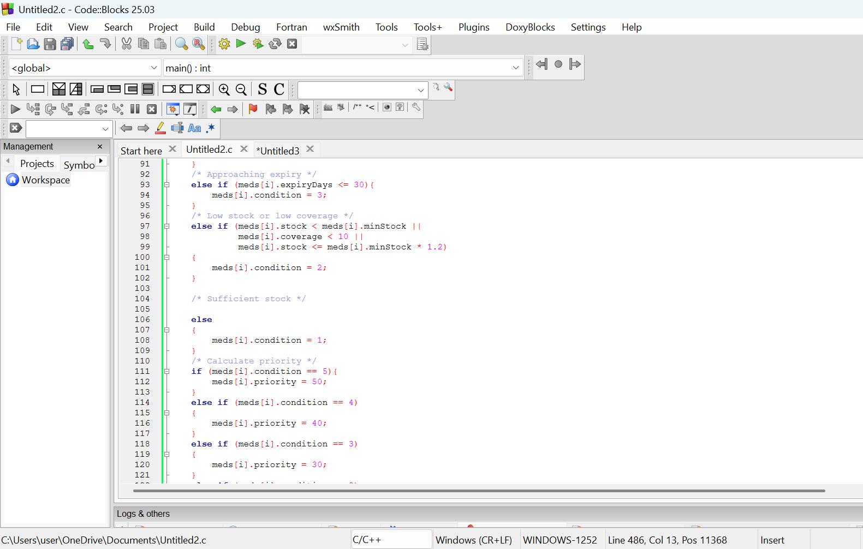

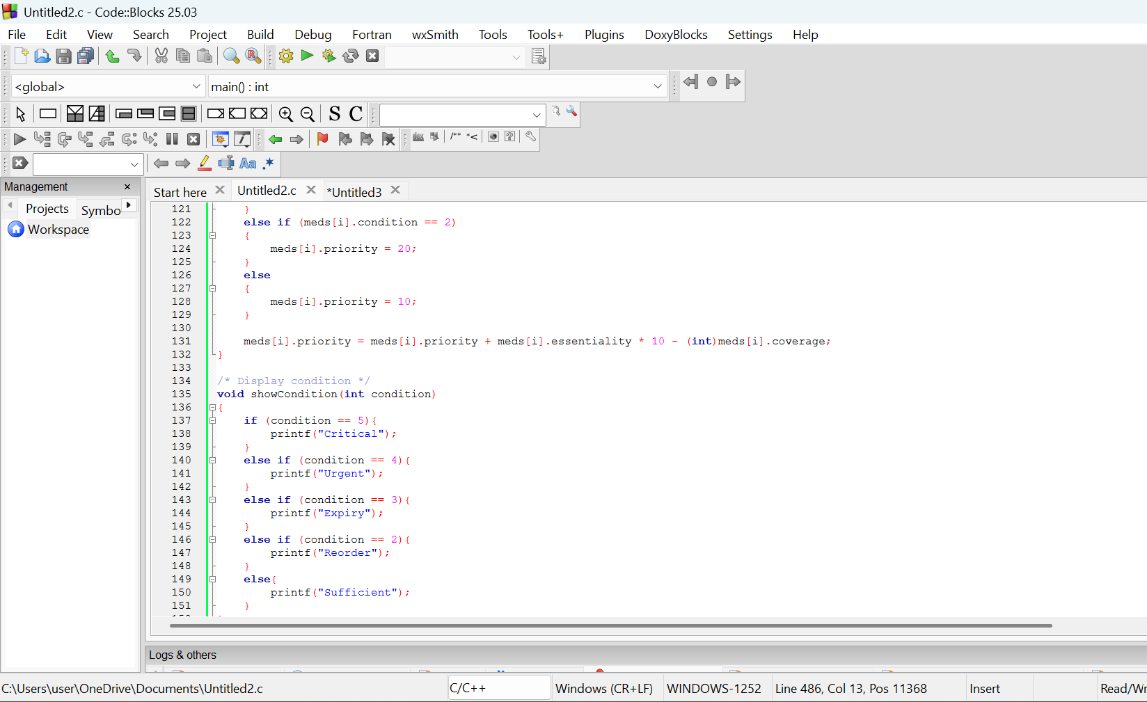

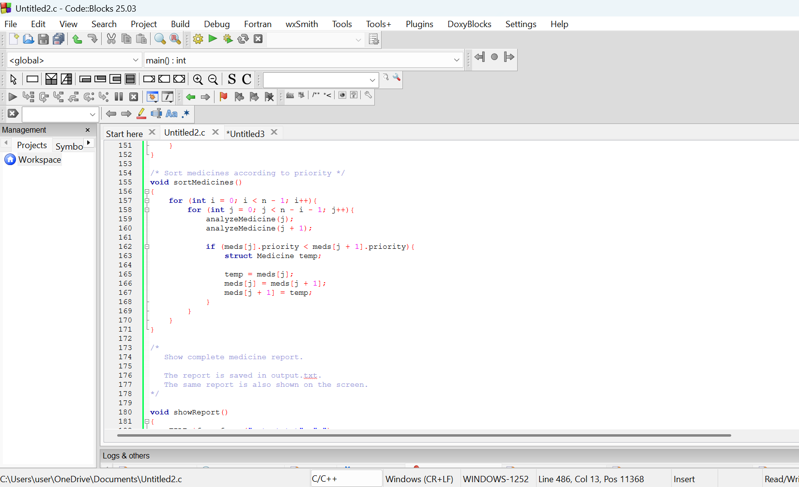

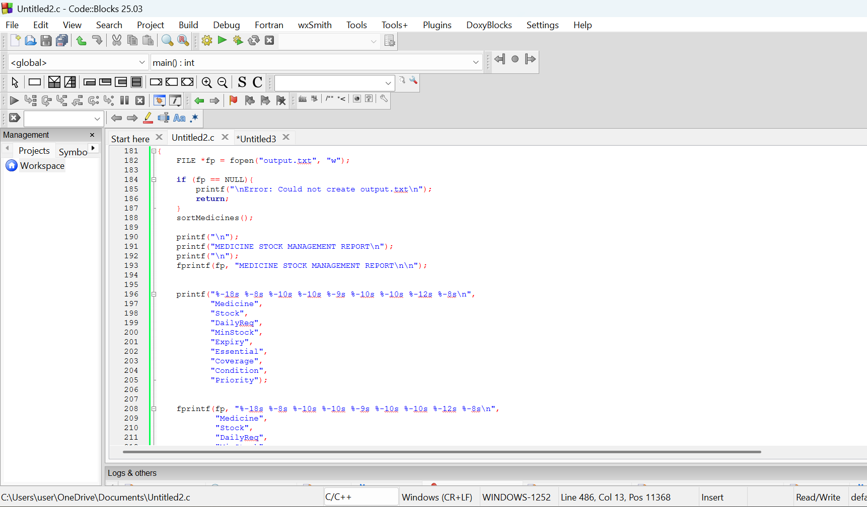

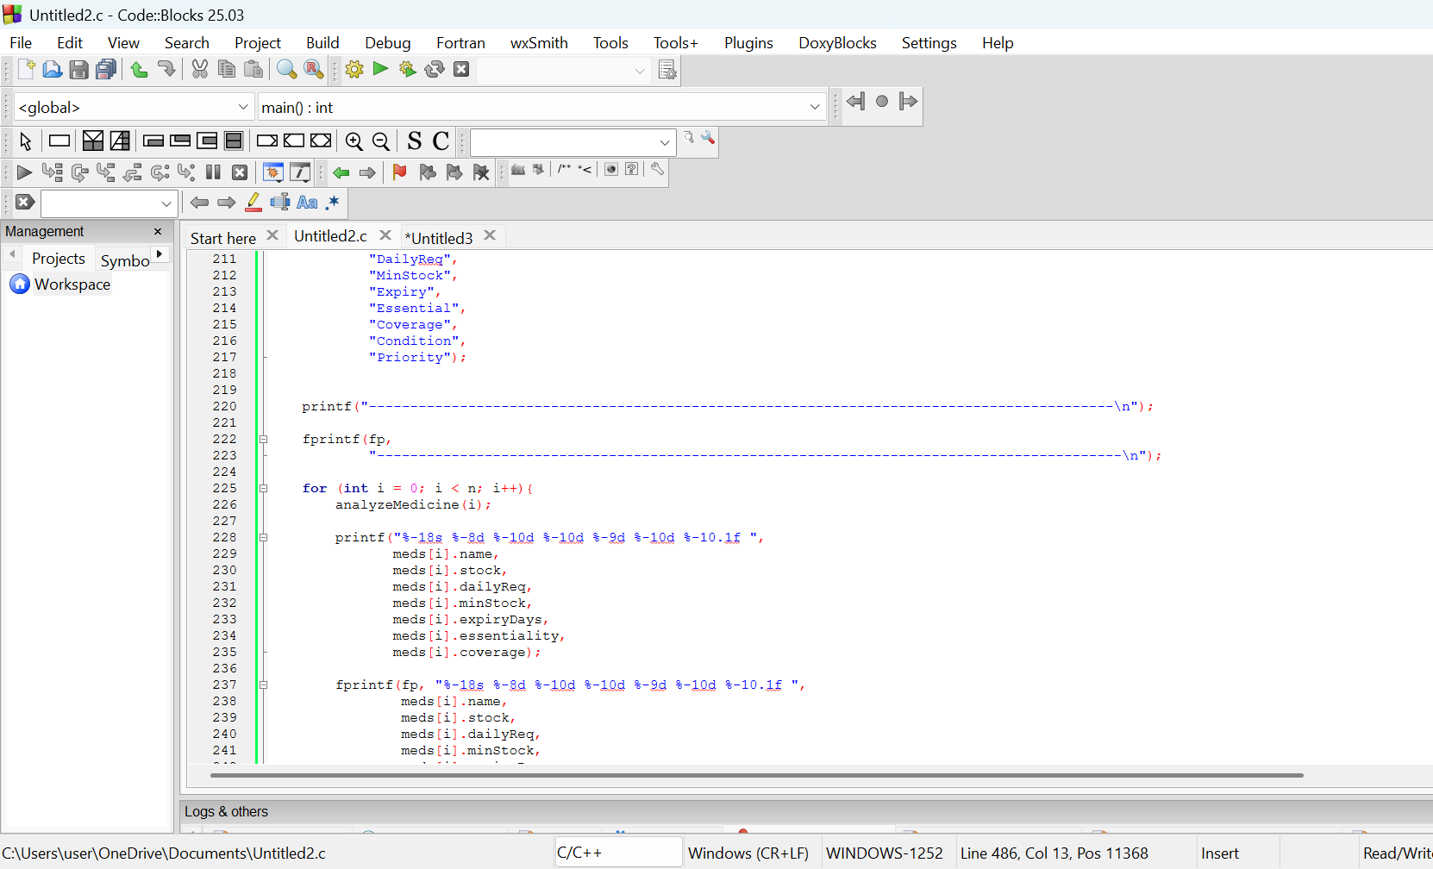

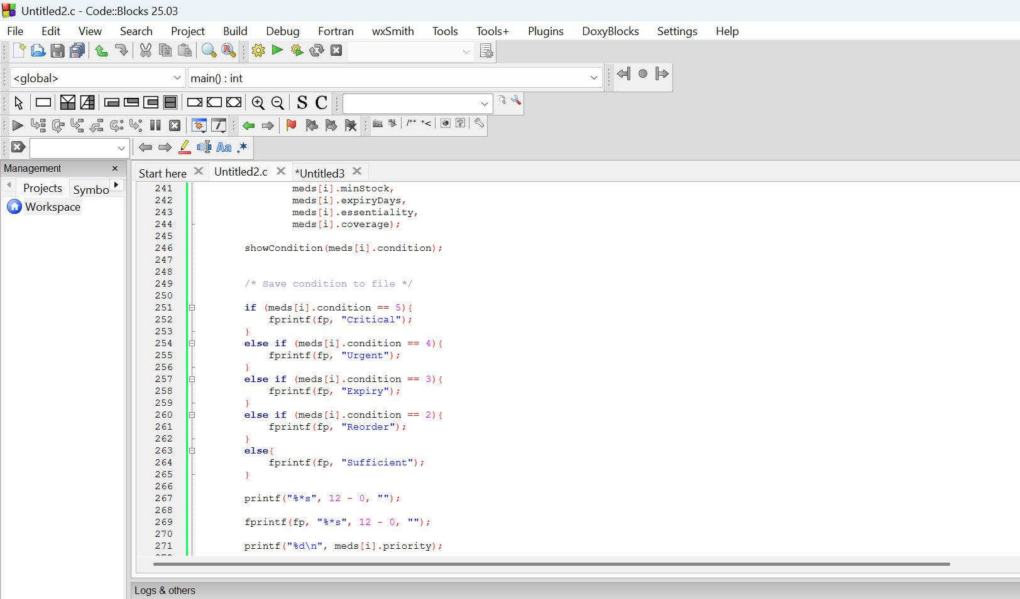

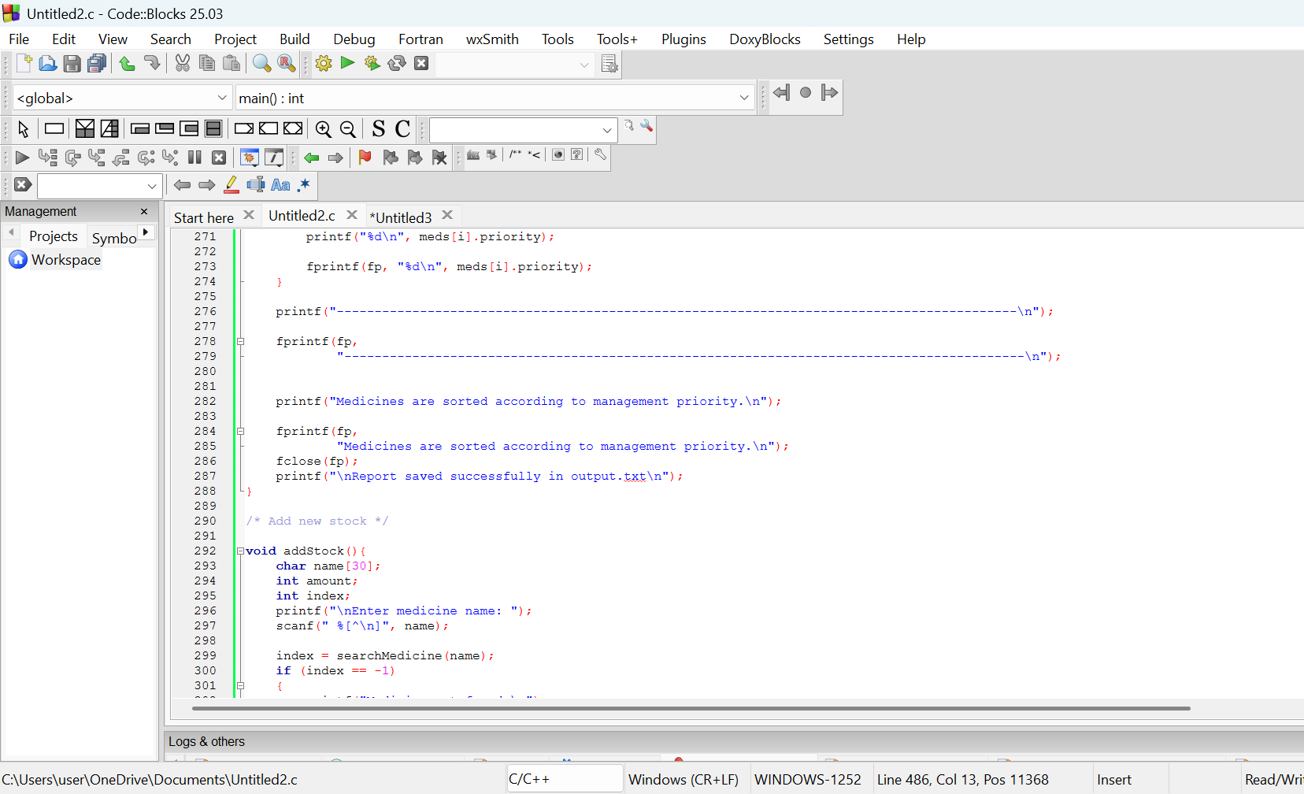

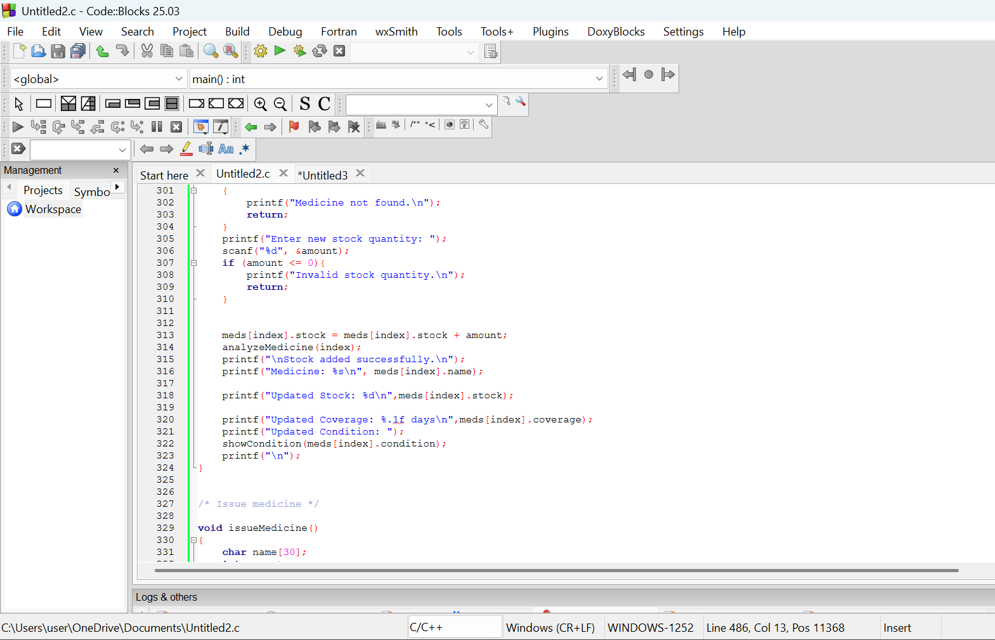

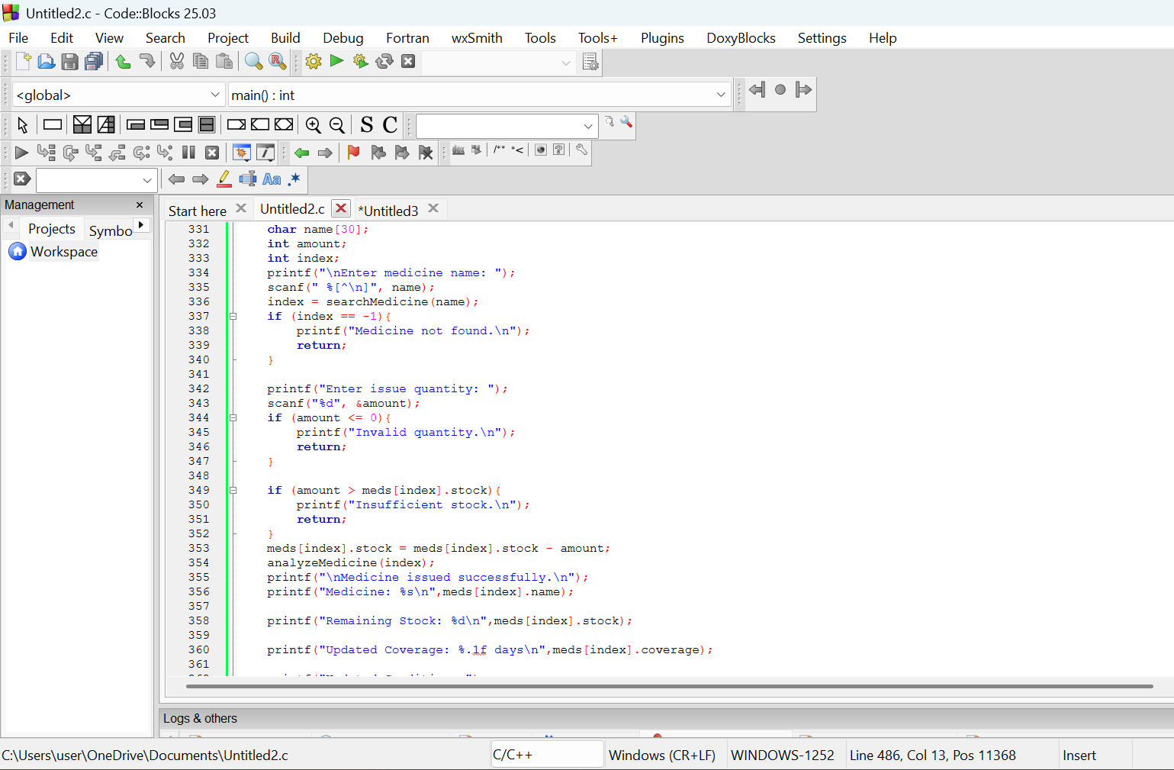

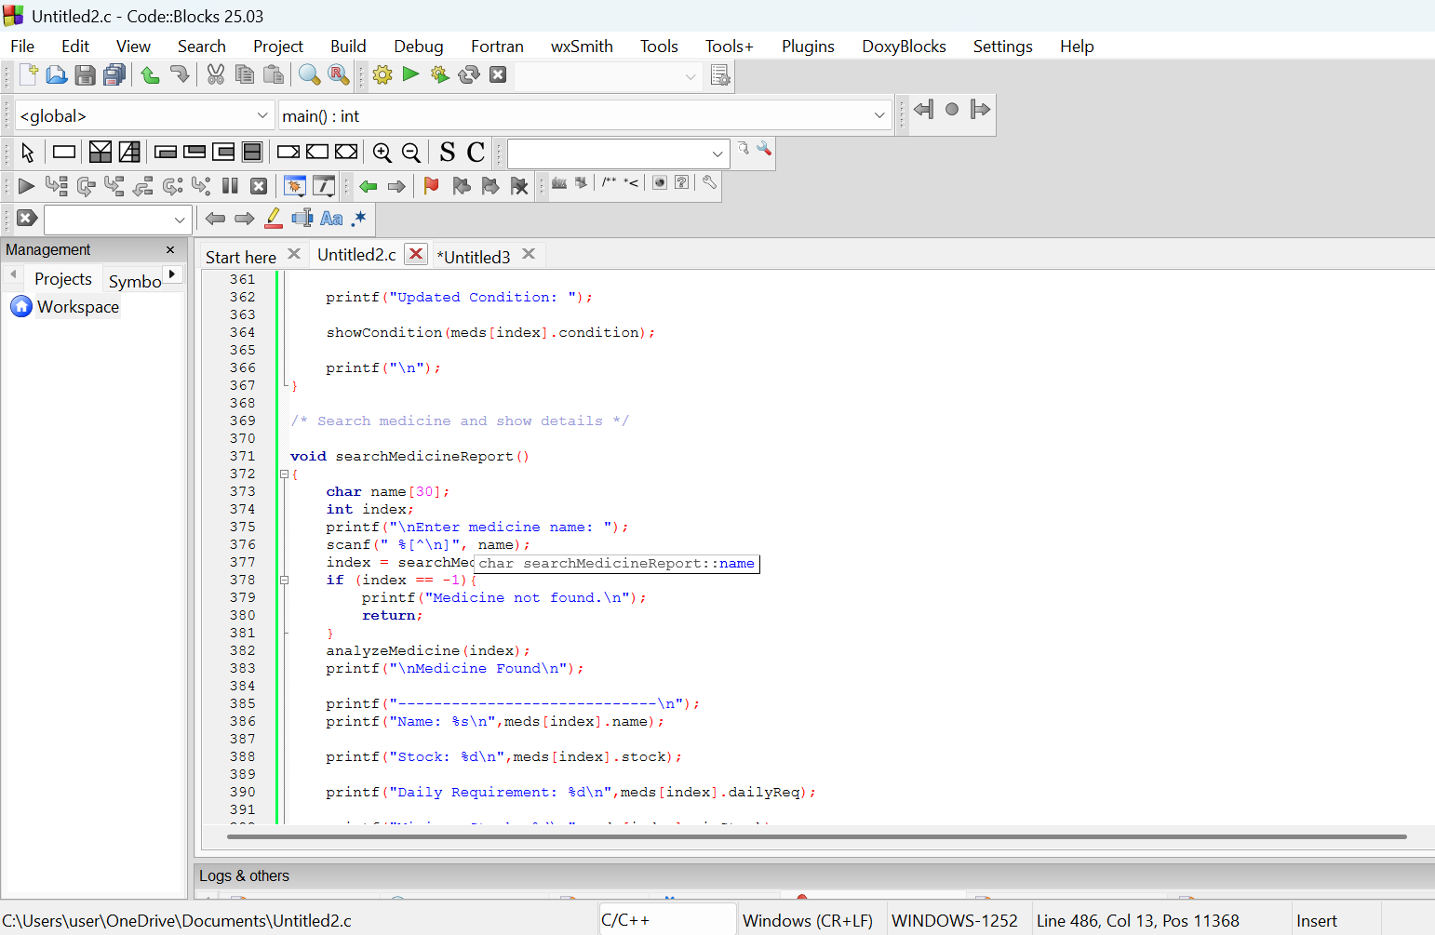

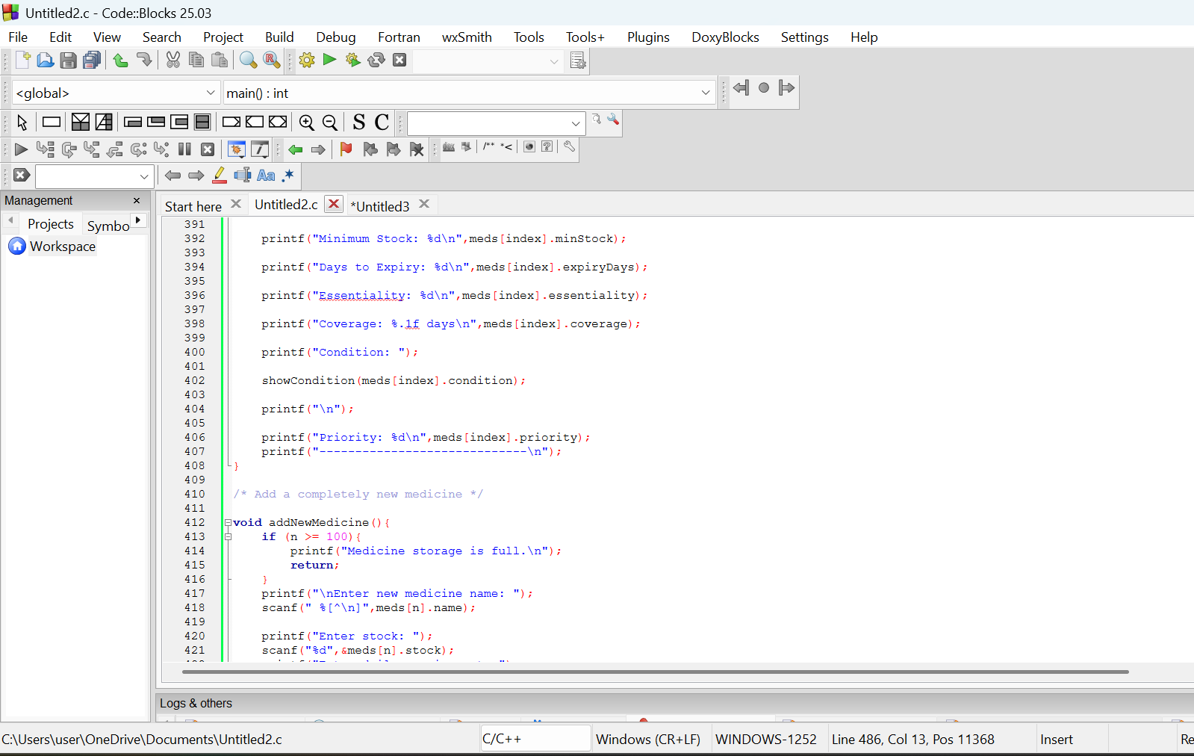

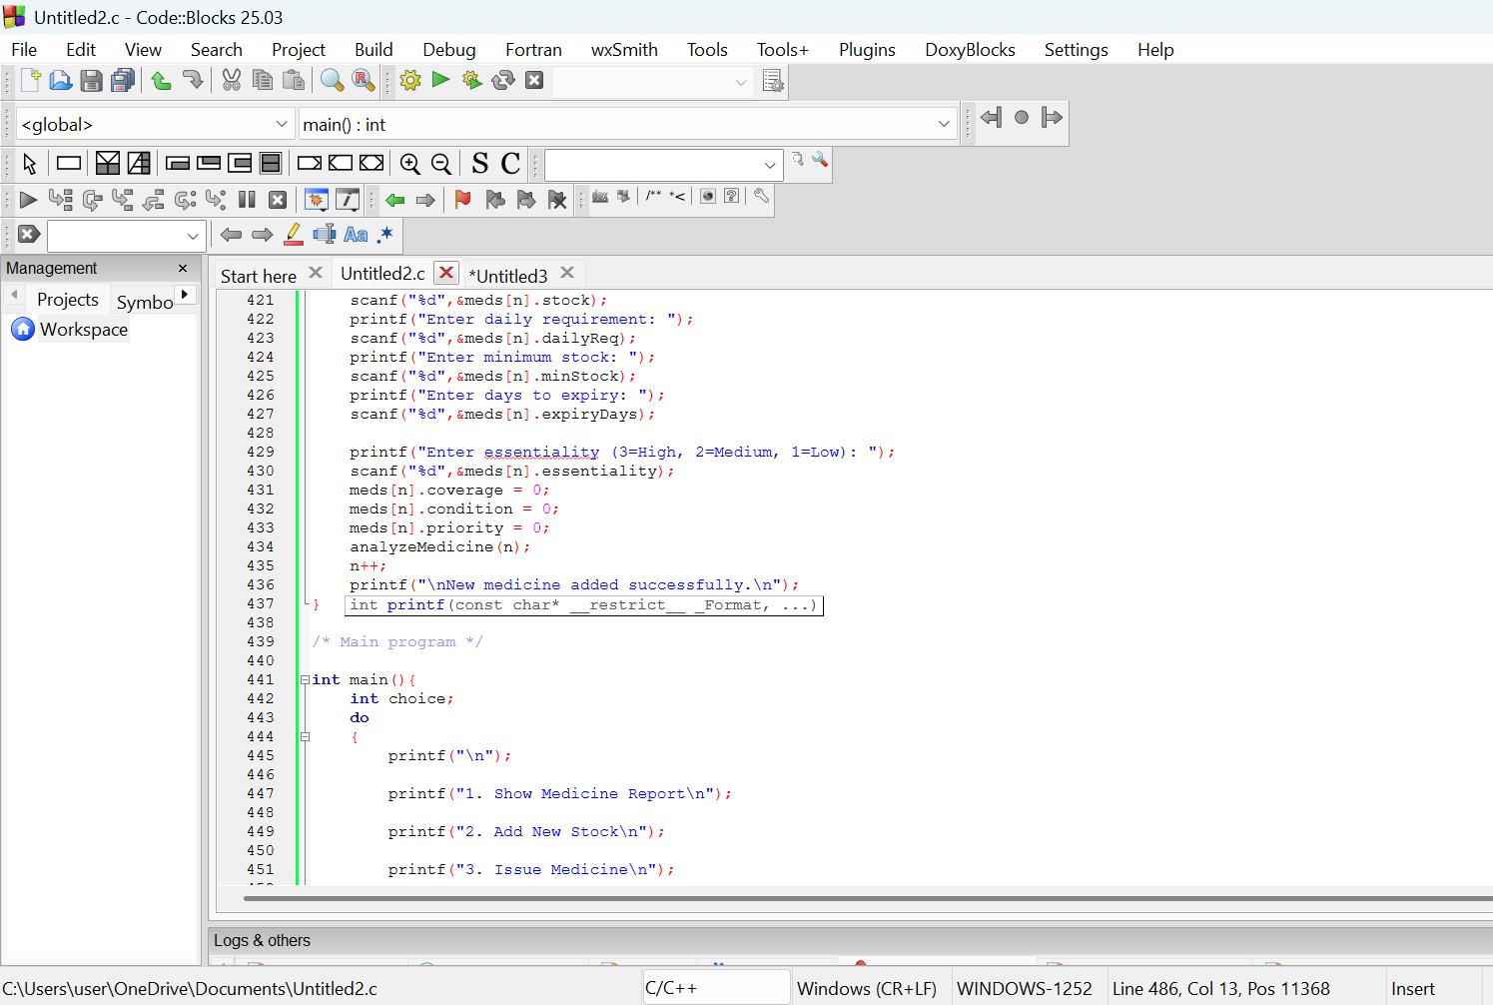

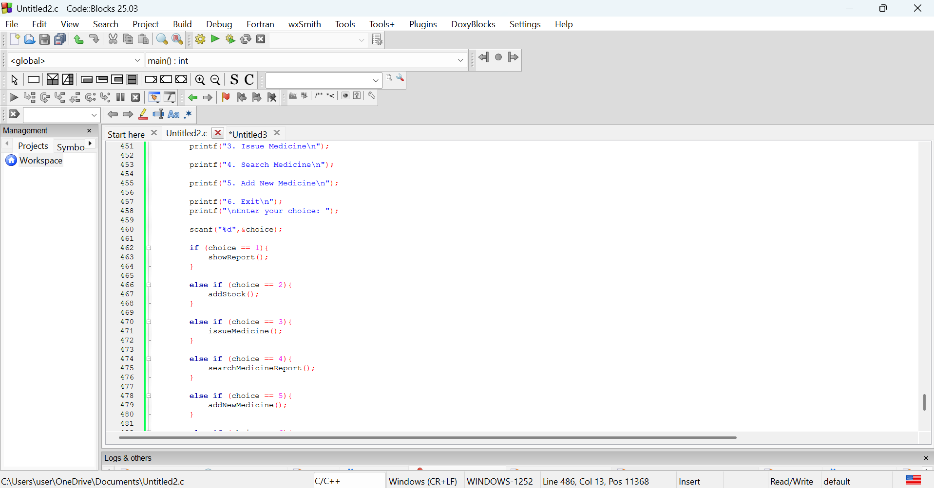

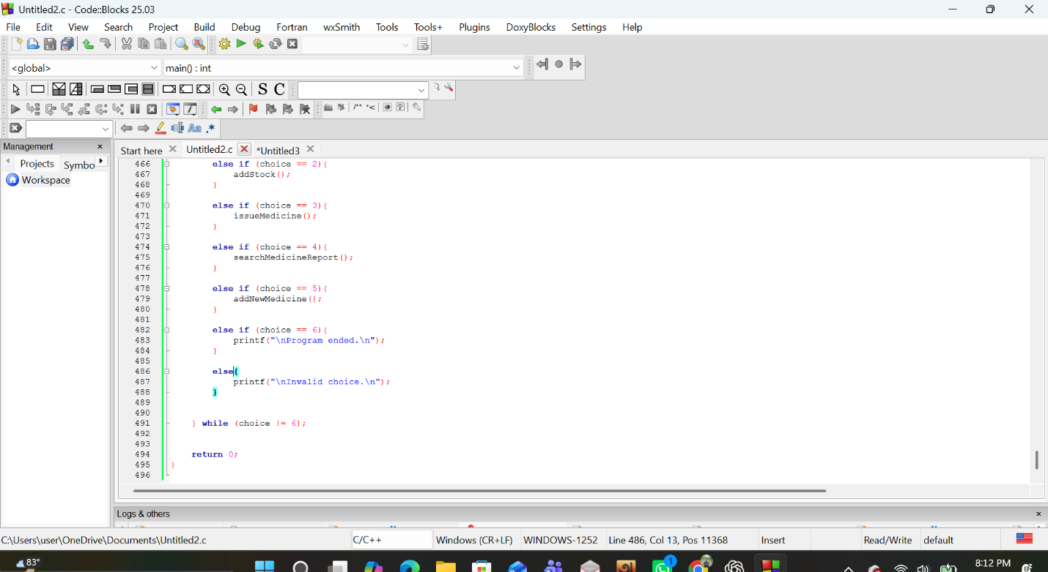

7.Testing and Validation

Program run

Case 1
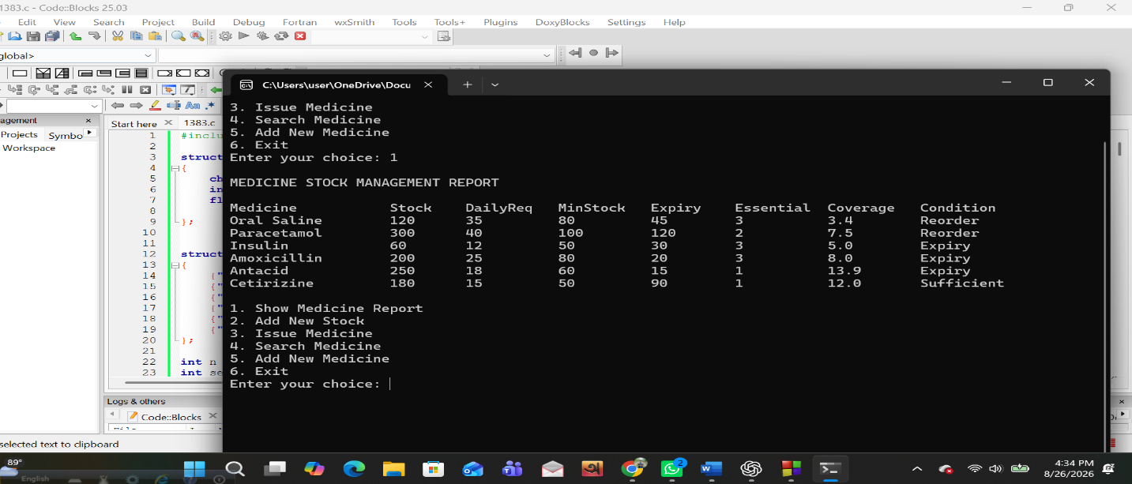

Case 2
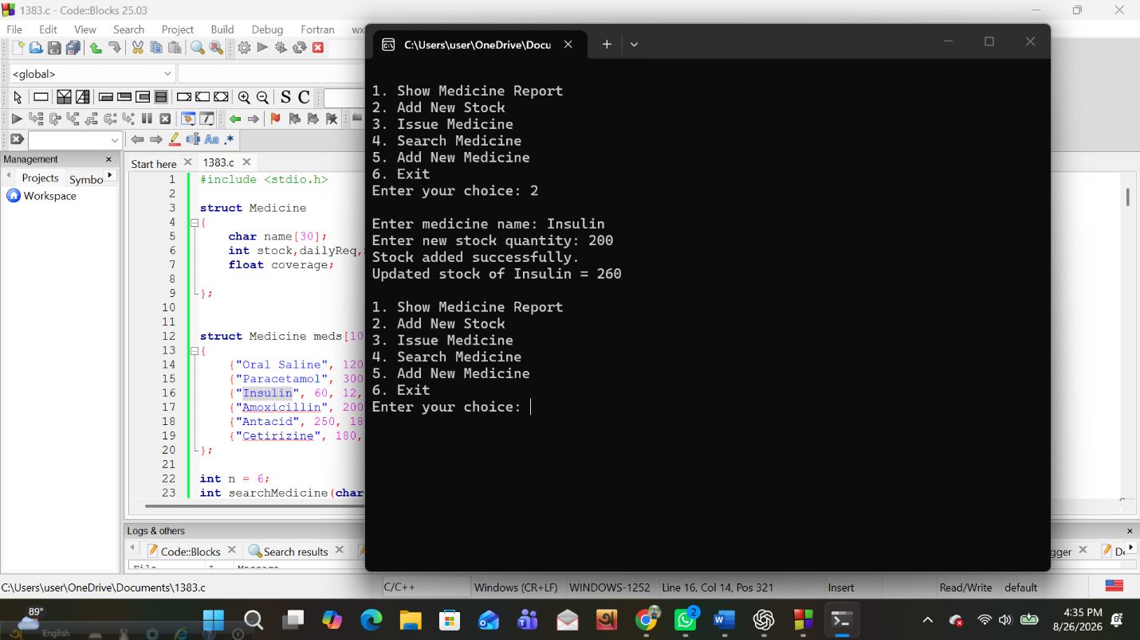
Case 3
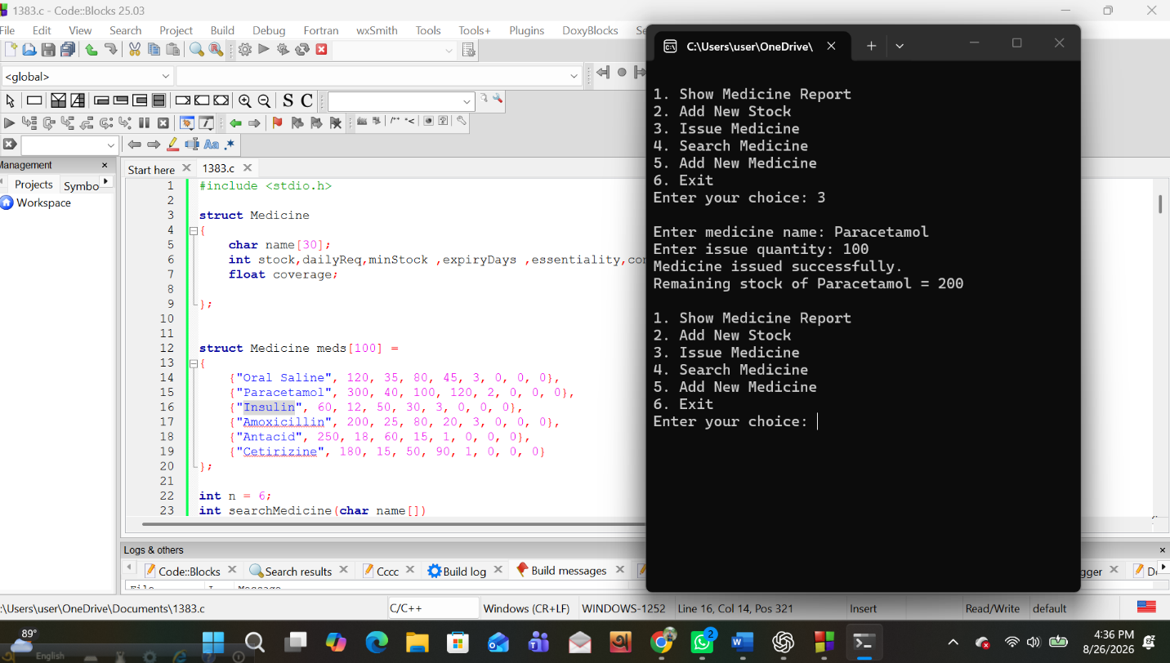
Case 4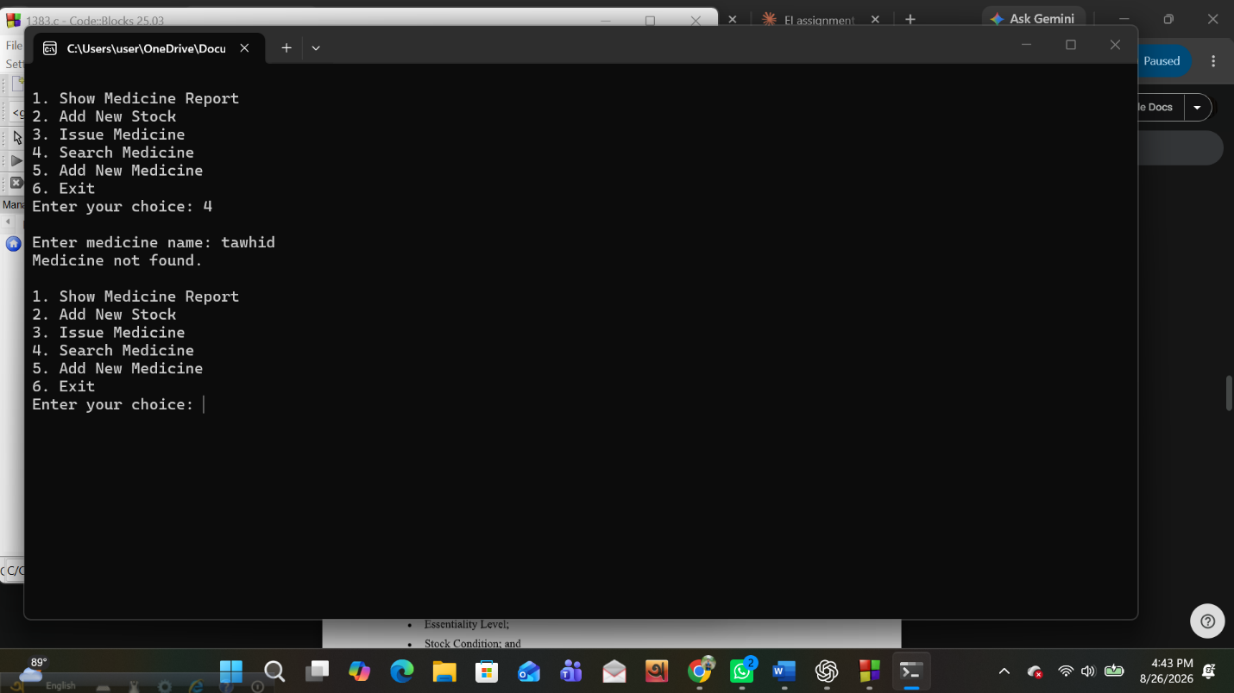

Case 5
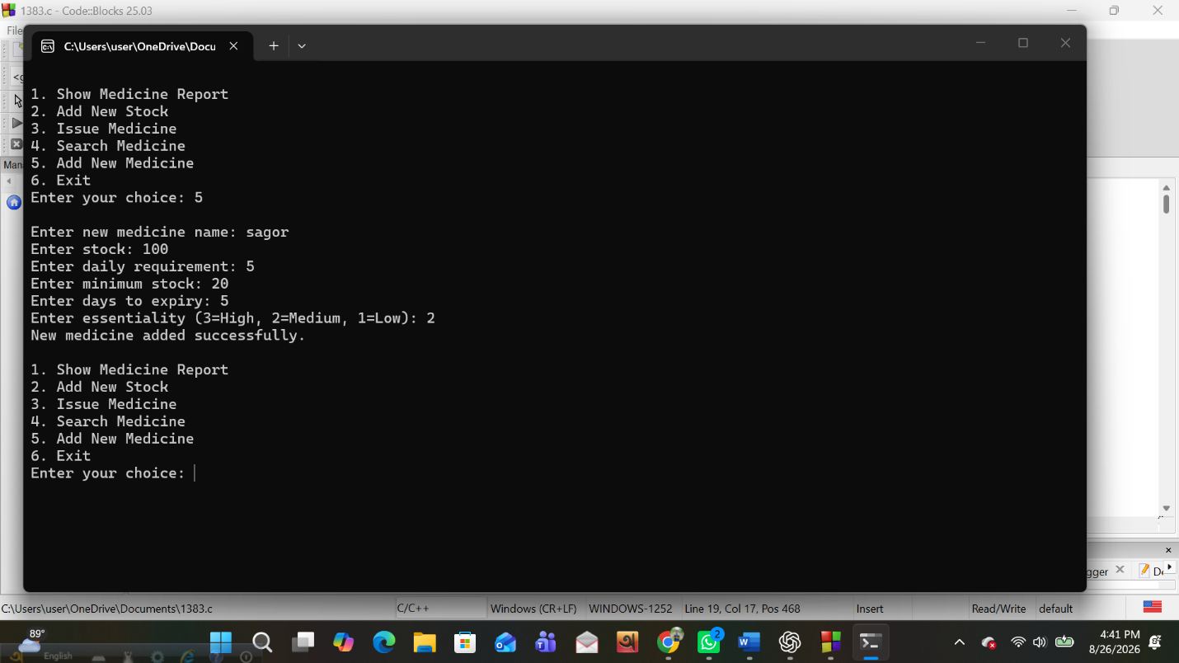

Case 6
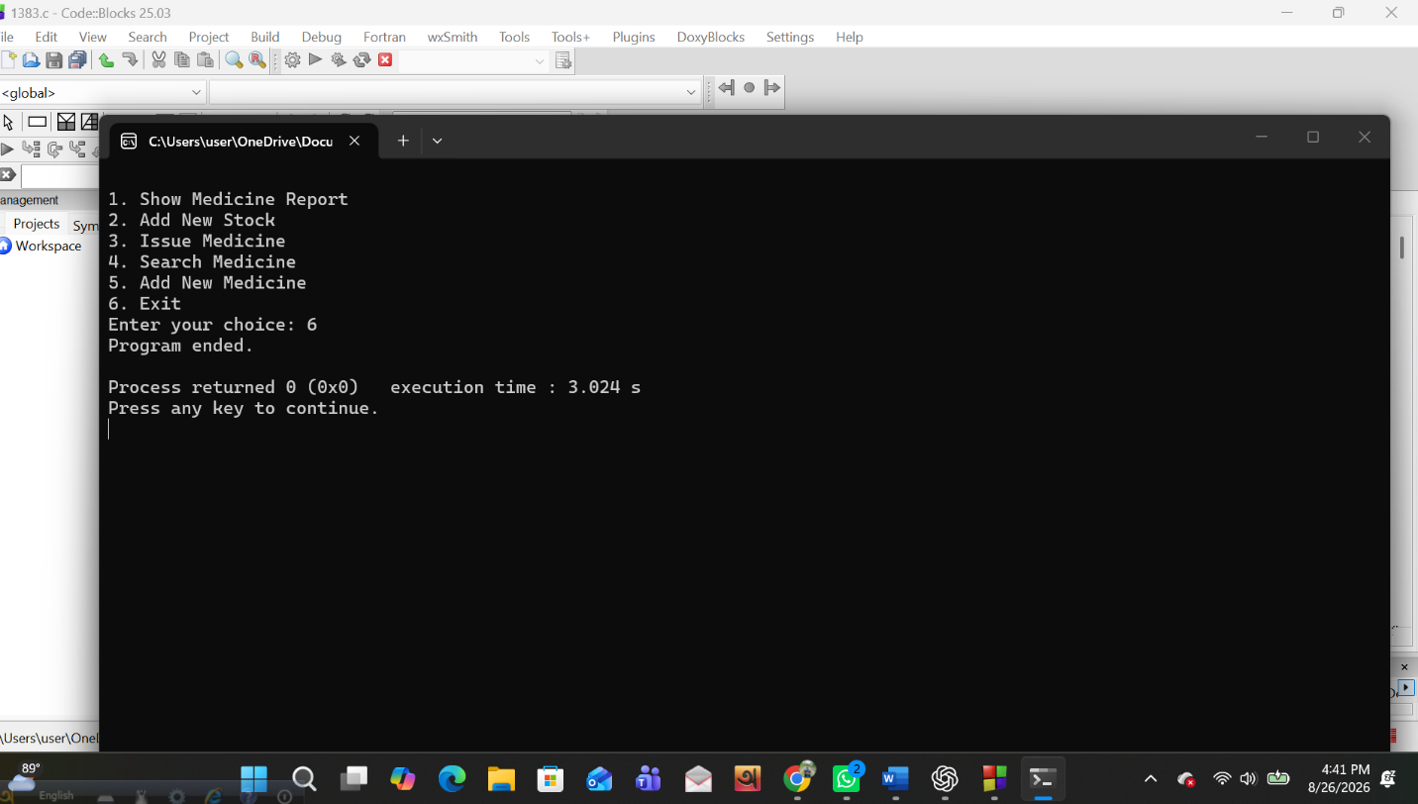

8. Limitations
The proposed solution rests on a number of assumptions and carries corresponding limitations that should be understood when interpreting its output.
- The average daily requirement recorded for each medicine is treated as a stable, representative rate of consumption; the program does not account for seasonal variation, disease outbreaks, or other irregular surges in patient demand that could alter this rate over short periods.
- The days remaining to expiry is treated as applying uniformly to the entire available stock of a medicine, since the supplied dataset does not distinguish between separate batches of the same medicine that may carry different expiry periods; a health center holding multiple batches with different expiry dates would need to extend the data organization described in Section 5.1 to a batch-level record.
- The minimum stock level and the essentiality level are treated as fixed reference values supplied by the center’s management; the program does not itself determine what these values ought to be, nor does it adjust them automatically over time.
- The dataset size assumed for demonstration is small, and the sorting technique selected in Section 6 is chosen accordingly; a very much larger medicine inventory would warrant reconsideration of the selected technique.
- The classification and priority methods described in Section 4 are one reasonable, explained approach among several that could satisfy the assignment brief, which explicitly permits students to adopt a different, justified classification; another reasonable method would be expected to produce broadly similar, though not necessarily identical, orderings on the supplied dataset.

9. Conclusion
This assignment required the design of a structured, C-language solution to a realistic inventory-management problem in which shortage risk and expiry risk must be considered together, rather than in isolation, and in which not every medicine carries the same clinical weight. The proposed solution derives a stock-coverage period and an expiry-exposure quantity for every medicine from the supplied data, uses these derived quantities together with the essentiality level to classify each medicine into one of five stock conditions, computes a combined priority indicator to order the medicines by the urgency of managerial attention they require, and resolves equal-priority cases through a short, reasoned sequence of secondary comparisons. The design keeps every derived value attached to the medicine record it describes, recalculates only what genuinely changes after a stock update, and is intended to remain correct when the supplied values, or the number of medicines, are changed, in line with the requirements stated in the assignment brief. Sections 7 and 8 of this report, concerning the implementation and its testing, are to be completed separately alongside the submitted source code and test evidence.

10. References
[1] Course materials and assignment brief, "Assignment on Medicine Stock and Expiry Management," CSC 1383 Structured Programming, Summer 2026.

